Revision
Science and Technology 3

LEARNING OBJECTIVES

At the end of this session, students will be able to:
- Apply the brainstorming strategies to an essay question (How far should medical resources be used to extend life expectancy?)
- Provide explanation to clarify the given stand and topic sentences

Part 1: Question Analysis
Instructions: Use the guiding questions provided to brainstorm for points using the keywords in the question. Write your brainstormed points in the ‘clarification’ section.
Remember that you are supposed to provide more than a mere definition of the keywords. Recall the brainstorming tools such as the PAL table and the EV lenses to extend your brainstorming.

How far should medical resources be used to extend life expectancy? (2011 A-level)

GUIDING QUESTIONS:
- Why do people want to extend their life expectancy? Is the extension of life really desirable for everyone?
- How are medical resources currently used to extend life expectancy?
  - Which corporations are pushing the frontiers in the use of medical resources to extend life expectancy?
  - Do all governments and societies have access to such medical resources?
- Who has the power to decide life and death if/when medical resources are used?
Note: You may wish to refer to Reading 2: Technology Aims to Bring Us Longer Lives. How Ethical is That? for more ideas for the argument for this question.
Key Terms | Clarification
Medical resources | Medication, treatments, equipment, and research that are used to treat medical conditions
Extend life expectancy | Prolong the life span; to help people live longer  Ethics / Moral angle - should humans try to artificially prolong their lives?  Environment/ Economics angle - are there enough resources to sustain such a large population?
How far should | To consider the necessity or consequences of using medical resources to prolong life - does it benefit the greater good?  (Note: there is a difference between ‘should’ and ‘can’. Responses should not focus on what medical resources can do. Attention should be on providing arguments to justify or to dissuade the use of medical resources to extend life expectancy.)

Part 2: Quality of Explanation
Instructions: For the following essay question, read the stand and provided TS. Then write an explanation to elaborate on the Topic Sentence
Recall - what makes a good Explanation?
- It should provide a reason for the argument in your Topic Sentence
- You should aim to provide a chain of Ex by continually asking How and Why questions
Stand: Medical resources should be used to extend life expectancy.
Topic Sentence: Medical resources should be used to extend life expectancy especially in countries where life expectancy is much lower due to widespread illness and disease that have already been eradicated in the developed world.
Explanation:
Hints:
- How are medical resources being used to tackle illness and disease?
- Why should people / medical professionals try to tackle the problem of widespread illness and disease?
This is where medical science can play a vital role because the industry is equipped with the professional expertise and logistics to craft solutions. Through medical research and the use of medical resources, we can advance our lives in definite ways. Also, there is a moral responsibility to care for people across the world, even when they are financially struggling to afford solutions. Medical resources should be shared with developing countries as it helps to lower the financial burden through their production in masses too.
Examples: For example, global medical cooperation and scientific research have significantly reduced deaths from infectious diseases in developing countries. One major example is the work of Gavi, the Vaccine Alliance and the World Health Organization, which launched “The Big Catch-Up” vaccination campaign after the COVID-19 pandemic. Since 2023, the initiative has delivered over 100 million vaccine doses to children across 36 countries, protecting millions against preventable diseases such as polio, measles and diphtheria.
Similarly, international medical funding has played a major role in combating diseases such as malaria, tuberculosis and HIV/AIDS. The Global Fund to Fight AIDS, Tuberculosis and Malaria reported that its programmes have helped save over 65 million lives since 2002 by funding treatments, vaccinations, mosquito-net distribution and healthcare infrastructure in poorer countries.
Evaluation: While it is gratifying that progress has been made over the years in helping to extend the life expectancy of people who may otherwise die prematurely due to preventable diseases, , their overall effectiveness is still limited by weak healthcare systems and unequal access to medical treatment, meaning that many vulnerable populations remain unable to fully benefit from these advancements.
Conclusion: Therefore, medical resources should continue to be used to extend life expectancy, particularly in developing countries where preventable diseases still claim many lives. By investing in medical research, vaccinations and accessible healthcare systems, governments and international organisations can help vulnerable populations live longer, healthier lives while narrowing global inequalities in healthcare access.

Stand: Medical resources should not be used to extend life expectancy.
Topic Sentence: The use of medical resources for prolonging life may cause a financial strain on society and, from a utilitarian perspective, it may not be for the greater good.
Explanation:
Hints:
- Why is the use of medical resources expensive?
- What is utilitarian? (recall your Ethics & Rights lesson notes)
- If too much is invested in medical resources to extend life expectancy, how will it affect the society as a whole? What are the possible trade-offs?
In practice, as medical resources are likely limited, they are appropriately employed only when maximised on those who will turn out to be the most economically productive. For nations with a rapidly greying population, the rationing of life-extending healthcare is difficult. While the health of the young can be ensured by relatively cheap preventive measures such as exercise programmes and health education, the medical conditions of the elderly are often complicated, requiring the use of expensive and yet often ineffective technologies and treatments.
Examples: Many societies are bracing themselves to manage the needs of an ageing population and medical needs of the old are costly. People are living longer but many are not ready or able to handle the rising medical costs that come with the extended life expectancy. In 2018, economists have analysed that healthcare inflation exceeds general inflation annually, and many Singaporeans will require more help with medical costs. Extending life expectancy would mean a larger bulk of society would be made up of the elderly and this would pose as a strain on the resources of the society as well as the elderly themselves.[CU – Connection(context)] [EV – other negative consequences] Worryingly, such medical treatments might not even be effective. A study by the American Medical Association revealed that it costs about four times the amount to treat a 65-year-old for healthcare in a given year than it does to treat a 40-year-old, yet up to 40% of the older population taking medications actually ends up with an adverse drug reaction.
Evaluation: To have enough resources to extend the mean lifespan of the average person, we may have to limit or even deny-life extending medical treatment to patients whose prognosis indicates a short life span, chronic illness, or little likely improvement in the quality of life. Unless medical resources and capabilities are able to ensure a good quality of life when life expectancy is extended, it would be hard to justify the strain on resources to prolong the misery of people.
Conclusion: From the utilitarian perspective, rationing of life-extending medical resources instead of helping all in need is therefore better because it allows the state to generate the greatest good for the greatest number of people.

Reading 1

Healthcare Technology Featured Article
July 10, 2017

4 Ways Technology Is Improving Life Expectancy

It’s common knowledge that our life expectancies have increased dramatically over the past few hundred years, but not many people realize exactly how this development came to be. According to the National Institute on Aging, most babies born in 1900 never made it past 50, while today’s leading country (Japan) boasts an average life expectancy of 83, with expectancies of 81 and above for many developed countries.
Much of this life expectancy increase is due to improved technology, but what types of technologies have been most important, and how could they develop in the future?

Main Areas of Technological Development
These are the main reasons life expectancy is so high (and continues to climb every year):
- Information. First, the rapid spread and availability of information has been pivotal—and it’s affected all three of the other dimensions we’re going to cover. The internet is the obvious example of faster communication and higher informational availability, but don’t discount the value of phones, or the public library system. Today, it’s easy to perform a basic online search and get instant information on an affliction or injury, potentially allowing you to provide early response efforts. You can also read information on health and fitness, and find tips on how to live a healthier lifestyle. You can even use the web to find a reliable health insurance provider, and get the medical coverage you need for a lower potential price. Without that readily available information, doctors and hospitals wouldn’t be able to exchange data with each other as quickly, and the general public would be in the dark about concepts of health and longevity we forget weren’t always common knowledge.
- Food production and distribution. It’s also amazing how far we’ve been able to improve food availability in the world. Though we’re still struggling with poverty and world hunger continues to be a problem, the amount of total food available per capita is astonishing. In the past few generations, we’ve been able to get more nutritious, bountiful crops out of the same patches of soil, and keep that food fresher, longer, as we distribute it across the world faster than ever before. If you’re reading this, you’ll likely never have to worry about going hungry or being undernourished—and that’s something past generations could only dream about.
- Public health. In the developed world, it’s easy to take clean water for granted. Poor sanitation standards in developing countries leave populations vulnerable to a host of different diseases, and just a hundred years ago, it was a leading cause of illness and death. Thankfully, we’ve been able to develop fully functional, safe ways to provide water to the masses and dispose of waste properly; the challenge now is making that technology available all over the world.
- Medicine. Last but certainly not least, we’ve seen a massive improvement in medical technologies, from vaccines that entirely eradicate diseases to medical equipment that can ease the burden of almost any chronic condition. Medical knowledge increases with every generation, and thanks to the compounding effects of that knowledge, we have access to medicines and treatments that no single person could discover in a thousand lifetimes.
Future Developments
Across all four dimensions, engineers and researchers are constantly striving for improvement. For example, our internet speeds keep getting faster and more available to pockets of the world that previously went without. Vertical farms are pushing the limits of how much food can be produced in a given physical space. Scientists are even finding ways to fight superbugs, which are typically unfazed by modern antibiotics.
Chances are, if you’re in reasonable health, you’ll be able to live well past 50—and it’s four main realms of technology that have helped make that a possibility. Try not to take them for granted.
Edited by Maurice Nagle
By Larry Alton , Special Guest Contributor, Alton Enterprises

Read more about the impacts of technology on ageing and longevity here below:
How Science, Technology, and Data are Contributing to a Longer and Better-Quality Life  (9 Feb 2023)   | What is the biggest benefit technology will have on ageing and longevity? (30 March 2021)  

Reading 2: Technology Aims to Bring Us Longer Lives. How Ethical is That?
By John K. Davis September 11, 2018 3:07 AM (https://www.discovermagazine.com/health/technology-aims-to-bring-us-longer-lives-how-ethical-is-that)
Life extension – using science to slow or halt human aging so that people live far longer than they do naturally – may one day be possible.
Big business is taking this possibility seriously. In 2013 Google founded a company called Calico to develop life extension methods, and Silicon Valley billionaires Jeff Bezos and Peter Thiel have invested in Unity Biotechnology, which has a market cap of US$700 million. Unity Biotechnology focuses mainly on preventing age-related diseases, but its research could lead to methods for slowing or preventing aging itself.
From my perspective as a philosopher, this poses two ethical questions. First, is extended life good? Second, could extending life harm others?
Is Living Forever A Good Thing?
Not everyone is convinced that extending life would be good. In a 2013 survey by the Pew Research Center’s Religion and Public Life project, some respondents worried that it might become boring, or that they would miss out on the benefits of growing old, such as gaining wisdom and learning to accept death.
Philosophers such as Bernard Williams have shared this concern. In 1973 Williams argued that immortality would become intolerably boring if one never changed. He also argued that, if people changed enough to avoid intolerable boredom, they would eventually change so much that they’d be entirely different people.
On the other hand, not everyone is persuaded that extended life would be a bad life. I’m not. But that’s not the point. No one is proposing to force anyone to use life extension, and – out of respect for liberty – no one should be prevented from using it. Nineteenth-century philosopher John Stuart Mill argued that society must respect individual liberty when it comes to deciding what’s good for us. In other words, it’s wrong to interfere with someone’s life choices even when he or she makes bad choices.
However, Mill also held that our liberty right is limited by the “harm principle.” The harm principle says that the right to individual liberty is limited by a duty not to harm others.
There are many possible harms: Dictators might live far too long, society might become too conservative and risk-averse and pensions might have to be limited, to name a few. One that stands out to me is the injustice of unequal access.
What does unequal access looks like when it comes to life extension?

Available Only to the Rich?
Many people, such as philosopher John Harris and those in the Pew Center survey, worry that life extension would be available only to the rich and make existing inequalities even worse.
Indeed, it is unjust when some people live longer than the poor because they have better health care. It would be far more unjust if the rich could live several decades or centuries longer than anyone else and gain more time to consolidate their advantages.
Some philosophers suggest that society should prevent inequality by banning life extension. This is equality by denial – if not everyone can get it, then no one gets it. However, as philosopher Richard J. Arneson notes, “leveling-down” – achieving equality by making some people worse off without making anyone better off – is unjust.
Indeed, as I argue in my recent book on life extension ethics, most of us reject leveling-down in other situations. For example, there are not enough human organs for transplant, but no one thinks the answer is to ban organ transplants.
Moreover, banning or slowing down the development of life extension may simply delay a time when the technology gets cheap enough for everyone to have it. TV sets were once a toy for the wealthy; now even poor families have them. In time, this could happen with life extension.
Justice requires that society subsidize access to life extension to the extent it can afford to do so. However, justice does not require banning life extension just because it’s not possible to give it to everyone.
Overpopulation Crisis?
Another possible harm is that the world will become overcrowded. Many people, including philosophers Peter Singer and Walter Glannon, are concerned that extending human life would cause severe overpopulation, pollution and resource shortages.
One way to prevent this harm, as some philosophers have proposed, is to limit the number of children after life extension.
This would be politically very difficult and very hard on those who want longer lives, but trying to ban life extension would be equally difficult, and denying people longer lives would be just as hard on them – if not more so. Limiting reproduction, as hard as that may be, is a better way to follow the harm principle.
Will Death Be Worse?
Another possible harm is that widespread life extension might make death worse for some people.
All else being equal, it is better to die at 90 than nine. At 90 you’re not missing out on many years, but at nine you lose most of your potential life. As philosopher Jeff McMahan argues, death is worse the more years it takes from you.
Now imagine that people living in a far wealthier neighborhood don’t have to die at 90 or so. They can afford life extension, and will live to 190. You can’t afford it, and you are dying at 80. Is your death not so bad, for you’re losing only a few years, or is your death now far worse, because – if only you had life extension – you might live to 190? Are you losing 10 years, or are you losing 110 years?
In a world where some people get life extension and some don’t, what’s the right measure for how many years death takes from you?
Perhaps the right measure is how many years life extension would give you, multiplied by the odds of getting it. For example, if you have a 20 percent chance of getting 100 years, then your death is worse by however many years you’d get in a normal lifespan, plus 20 years.
If so, then the fact that some people can get life extension makes your death somewhat worse. This is a more subtle kind of harm than living in an overpopulated world, but it’s a harm all the same.
However, not just any harm is enough to outweigh liberty. After all, expensive new medical treatments can extend a normal lifespan, but even if that makes death slightly worse for those who can’t afford those treatments, no one thinks such treatments should be banned.
I believe that life extension is a good thing, but it does pose threats to society that must be taken seriously.

READING 3: The Singapore Context
Aug 08, 2018
Singapore’s science and technology transformation over 50 years mirrors her remarkable leap from survival to excellence.
Fifty years ago, technology served a functional role, today it is the central engine powering an ambitious economy. Singapore's water technology, port management capability and petrochemical ecosystem are noteworthy. With the increasingly competitive global technology landscape, it is crucial that Singapore constantly adopts innovative technologies to sustain and bolster economic competitiveness.
This requires a hands-on approach in creating a culture of innovation, and paradoxically a somewhat hands-off approach to allow intellectual germination especially through entrepreneurship and research. Against this background, policies designed to establish operational transparency enable agencies to ensure responsible implementation, instill accountability as well as legal and constitutional compliance.
We review Singapore’s Science and Technology (S&T) journey in the context of its 50-year transformation from a developing nation to a thriving first world metropolis.
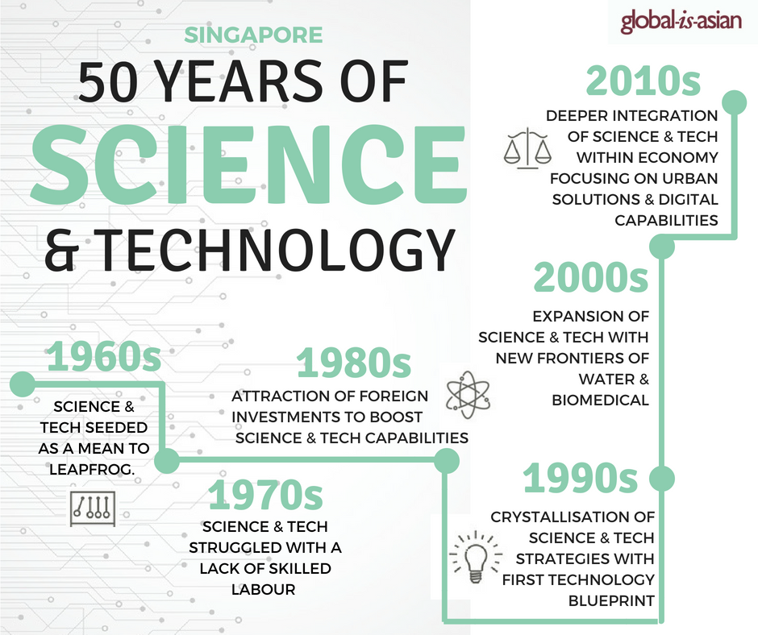
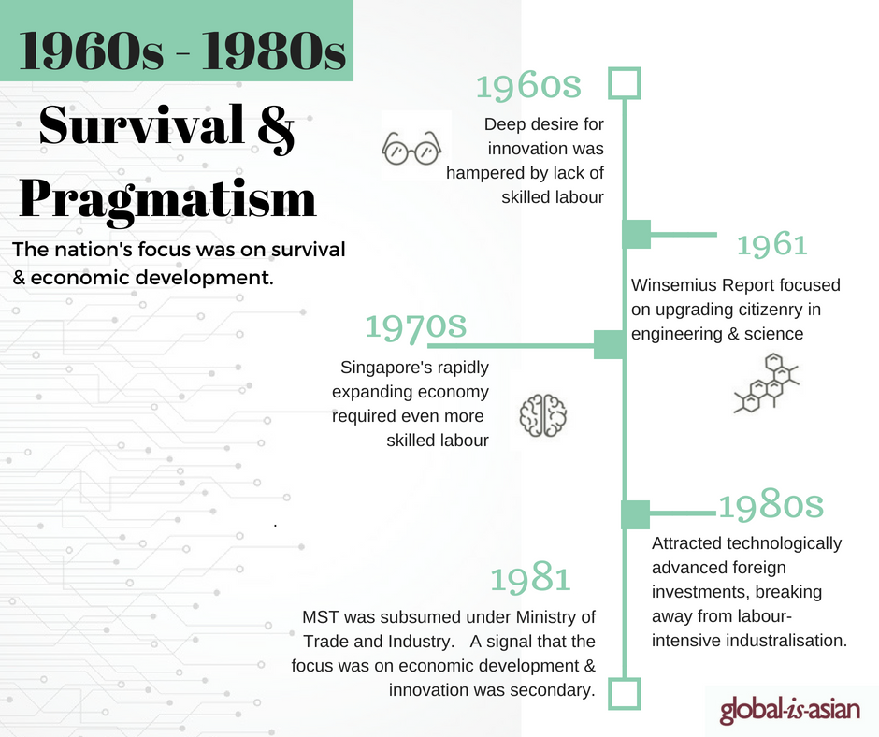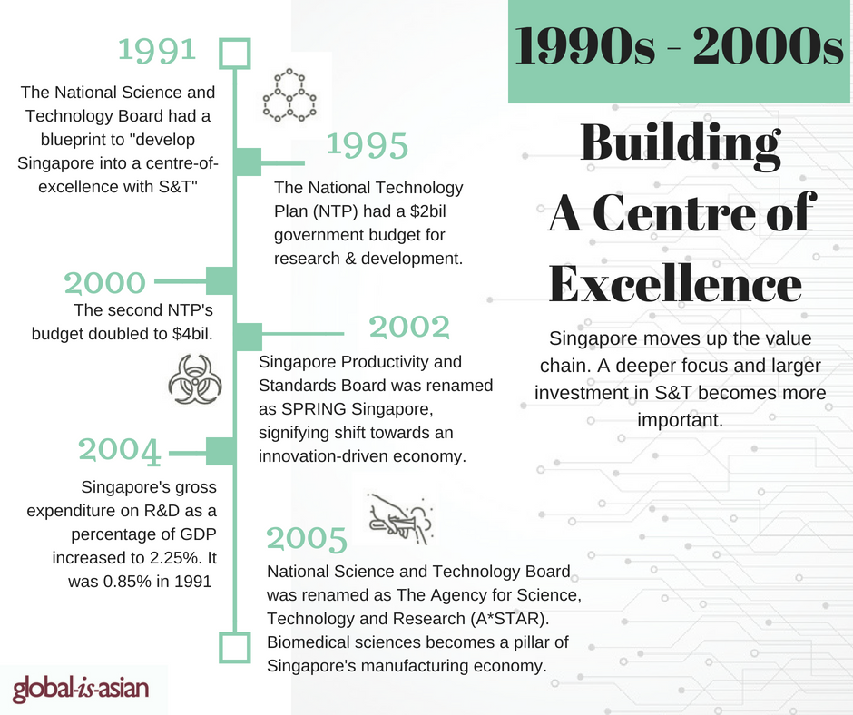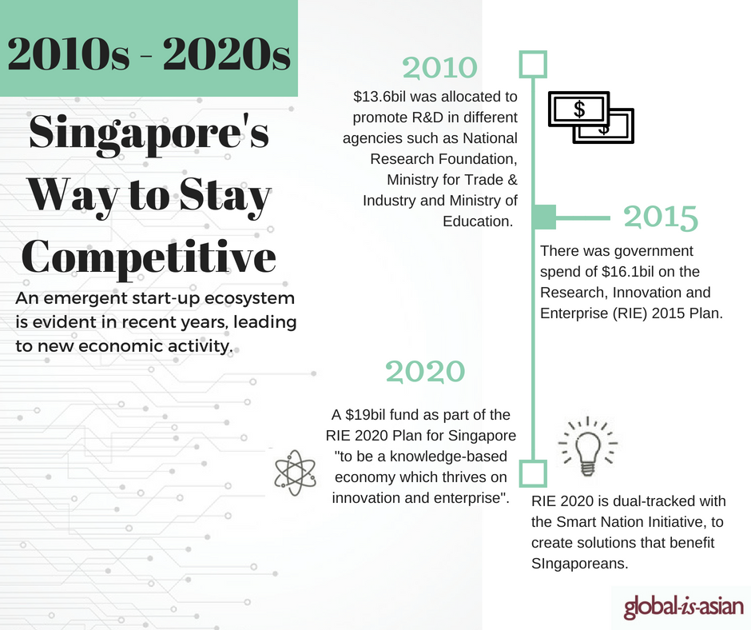

The Singapore Context - The Pursuit of Knowledge, or Plain Survival?
In the years leading up to and after independence in 1965, entrepôt trade was the mainstay of the Singapore economy. The fledgling nation, in order to survive, had to find means to leapfrog technologically to make up for the constraints of its physical and resource limitations.
With people as Singapore’s most valuable resource, it was recognized early on that leading in the field of science and technology will set it apart.
The Ministry of Science and Technology (MST), Singapore Institute of Standards and Industrial Research (SISIR) and the Science Council of Singapore (SCS) were established in the late 1960s to lead and implement science and technology policies, as well as to build research and development (R&D) capabilities. Whilst the need for S&T was anticipated and the intentions good, the timing and environment were not conducive for Singapore.

The Human Resource Struggle
Firstly, there was a dearth of able and knowledgeable citizens who could pursue S&T as researchers; many Singaporeans then were traders or unskilled laborers.
Secondly, the pressing need for Singapore in the 1960s was to create jobs and industrialize the economy. The 1961 Winsemius Report and the subsequent State Development Plan[1]
However, Singapore continued to struggle in building a critical mass of scientists and engineers who were willing to pursue R&D. Acknowledging that more had to be done to be a true knowledge-based economy, Singapore forged ahead to create a conducive climate for R&D within S&T.
The National Science and Technology Board (NSTB) succeeded in 1991 with a clear blueprint “to develop Singapore into a centre-of-excellence in selected fields within S&T so as to enhance our national competitiveness in the industrial and services sectors”[2].
The first National Technology Plan (NTP) outlined Singapore’s R&D policy in 1990s to cultivate a rich research ecosystem and culture, augment funding, train researchers, and build infrastructure.
NSTB subsequently restructured to become A*STAR in 2001. SISIR also merged with the National Productivity Board (NPB) to form the Singapore Productivity and Standards Board (PSB).
In April 2002, PSB was renamed SPRING Singapore to signify the shift towards an innovation-driven economy, and its new role in promoting creativity and raising the productivity of the domestic sector to sustain growth for Singapore and Singaporeans.[3]
With the repurposed statutory boards imbued with a clear purpose, direction and mandate, the following decades saw five bold masterplans to power Singapore’s ambitions in science and technology.

Singapore’s Six Masterplans for Science and Technology
1. National Technology Plan 1995
Focusing on economically driven R&D, the NTP’s execution was spearheaded by the NSTB with the injection of S$2 billion for its fulfilment.
The five-year plan served as the blueprint for R&D development in nine sectors: information technology; microelectronics; electronic systems; manufacturing technology; materials technology; energy, water, environment and resources; food and agro technology; biotechnology; and medical sciences.
2. National Science and Technology Plan 2000
The second five-year plan doubled the budget to $4 billion to build on the much-needed efforts to develop Singapore’s S&T infrastructure.
The nine sectors earmarked as part of the Singapore’s Strategic Economic Plan continued to benefit from the focus of strengthening the local labour force and indigenous R&D capability as well as a greater support for industry R&D.
In 2003, Singapore was struck by one of the worst crisis in living memory: the severe acute respiratory syndrome (SARS) outbreak. It is with extraordinary prescience that Singapore has the ready biomedical infrastructure in place to meet with this calamity.
3. Science and Technology Plan 2005
Another S$1m was added to the original budget to S$7 billion, where S$5 billion was managed by NSTB with the remaining allocated EDB. NSTB worked to develop the nation’s human and intellectual capital, whilst EDB pursued industrial capital development. [4]
It was during this phase that NSTB was renamed as The Agency for Science, Technology and Research (A*STAR). It also marked the start of Singapore’s pursuit of Biomedical Sciences (BMS) as its fourth pillar of the manufacturing economy (alongside Electronics, Engineering and Chemicals).
Of note was the establishment of the Bioengineering and Nanotechnology (IBN) resulted in achievements such as genetic engineering techniques for stem-cell cancer therapy.
These years saw the attraction of many renowned scientists like Professors Edison Liu and Sir David Lane, as well as the forging of many international collaboration and partnerships.
Biopolis, an iconic biomedical R&D centre that houses leading companies and diverse talents in the field, deepened Singapore’s knowledge based. It took less than three years from concept-to-opening—the breathtaking pace signalled Singapore’s commitment to S&T.
Over the three national S&T plans, Singapore’s Gross Expenditure on R&D (GERD) as a percentage of GDP increased from 0.85% in 1990 to 2.25% in 2004, comparable with advanced economies like the US and Japan.
The number of Research Scientists and Engineers in Singapore grew significantly, from 28 in 1990 to 87 per 10,000 labour force in 2004.[5]
4. Science and Technology Plan 2010
Set up in 2006, the Research, Innovation and Enterprise Council (RIEC) is represented by high level government officials, prominent industry captains, and internationally renowned individuals from the scientific and academic community. National Research Foundation (NRF) was also formed to support the RIEC through policy formulation and implementation.
$13.55 billion was earmarked to different agencies to promote R&D - $5 billion allocated to the NRF for longer-term strategic programmes, $7.5 billion to the MTI for economic-oriented R&D and related investment promotion activities, and $1.05 billion to the Ministry of Education (MOE) for academic research.
The goal is to achieve a GERD of 3% of GDP by 2010. Alongside, there is continued emphasis that research should translate to technologies that power industry growth.
Environmental and Water Technologies sector and the Interactive and Digital Media sector were identified as rapid growth areas for development. Fusionpolis, a focal point for the physical sciences and engineering clusters, was modelled after Biopolis and opened in 2008.
5. Research, Innovation and Enterprise 2015 (RIE2015) Plan
The RIE2015 plan built on the momentum set in the 2010 plan with 6 key thrusts highlighted by Deputy Prime Minister Teo Chee Hean[6]:
- Continued emphasis on basic science and knowledge as basis of future innovations.
- Focus on talent attraction and development, positioning Singapore as choice location for researchers
- Greater emphasis on competitive funding as a selection means for the best ideas for optimal resource allocation
- Fostering greater synergies between private and public and more funding for multi-disciplinary breakthrough science
- Heavier weighting of R&D to promote positive economic outcomes
- Strengthen support for commercialization to encourage development of products and services
6. Research, Innovation and Enterprise 2020 (RIE2020) Plan
In its largest R&D investment to date, Singapore renewed its commitment in R&D in the form of a S$19 billion fund “to be a knowledge-based economy which thrives on innovation and enterprise”[7].
Singapore’s strong scientific based is underpinned by growing numbers of Research and Engineers (RSEs) in the workforce. Its university rankings as well as their field-weighted citation impact (FWCI) have trended higher over the years – a testament to the country’s focus on S&T excellence.
Singapore’s pragmatism continues to align R&D efforts with industry demand, creating more jobs and generating higher value products and services. Industry-science linkages deepen with continued tie-ups in a variety of sectors e.g. SingHealth/Duke-NUS Joint Strategic Research Masterplan and A*STAR Aerospace Research Consortium.
This strategy extends the value chain of research beyond publications and patents to products and solutions.
An emergent start-up ecosystem is evident in the recent years, leading to new economic activity. Singapore commits to building a conducive climate for idea incubation with incentives to nudge potential entrepreneurs towards Singapore’s priority sectors of tomorrow.

Staying Ahead in a Competitive World
Essentially, RIE2020 builds on RIE2015 by establishing a framework to prioritise funding for four strategic technology domains, underpinned by three cross cutting programmes. With the inevitable influence of information technology in our lives, the four technology domains are also threaded together with a digital focus to revolutionize the way citizens live their lives.
RIE2020 is part of the broader Smart Nation strategy: Leveraging research funding and findings to create innovative solutions that benefit Singapore and Singaporeans.
On the policy front, Singapore’s latest innovation leverages on a whole-of-government approach as evident by recent initiatives:
1. Centralising regulatory agencies: Merging of Infocomm Development Authority (IDA) and Media Development Authority (MDA) to form Infocomm Media Development Authority (IMDA)
2.Launch of SGInnovate dedicated to support Singapore’s start-up ecosystem
3. Bringing strategy and implementation under one agency: Integrating the Smart Nation Program Office (strategy) and GovTech (implementation) to form the Smart Nation and Digital Government Office (SNDGO).
In conclusion, it is remarkable that a small country in 50 years could transform rapidly—economically and technologically.
Looking ahead, Singapore would do well to forge closer integration along and across value chains. Specifically, structuring funding for academia to collaborate with industry nudges collaboration along the value chain where prototypes have a better chance for commercialization.
[1] Lee Soo Ann, Industrialization in Singapore (Camberwell, Australia:Longman, 1973), p.112
[2] National Technology Plan 1991 (Singapore: National Science and Technology Board, 1992), p. ii.
[3] Wee, Jane (29 May 2003). "SPRING Singapore (Standards, Productivity and Innovation Board)". National Library Board.
[4]https://www.mti.gov.sg/ResearchRoom/Documents/app.mti.gov.sg/data/pages/885/doc/S%20And%20T%20Plan%202010.pdf
[5] S&T Plan 2010. (n.d.). Retrieved fromhttps://www.mti.gov.sg/ResearchRoom/Documents/app.mti.gov.sg/data/pages/885/doc/S And T Plan 2010.pdf
[6] Research, Innovation and Enterprise (RIE) 2015. Retrieved from https://www.mti.gov.sg/ResearchRoom/Pages/Research,-Innovation-and-Enterprise-(RIE)-2015.aspx
[7] Research, Innovation and Enterprise 2020 Plan (n.d.). Retrieved from https://www.nrf.gov.sg/rie2020

